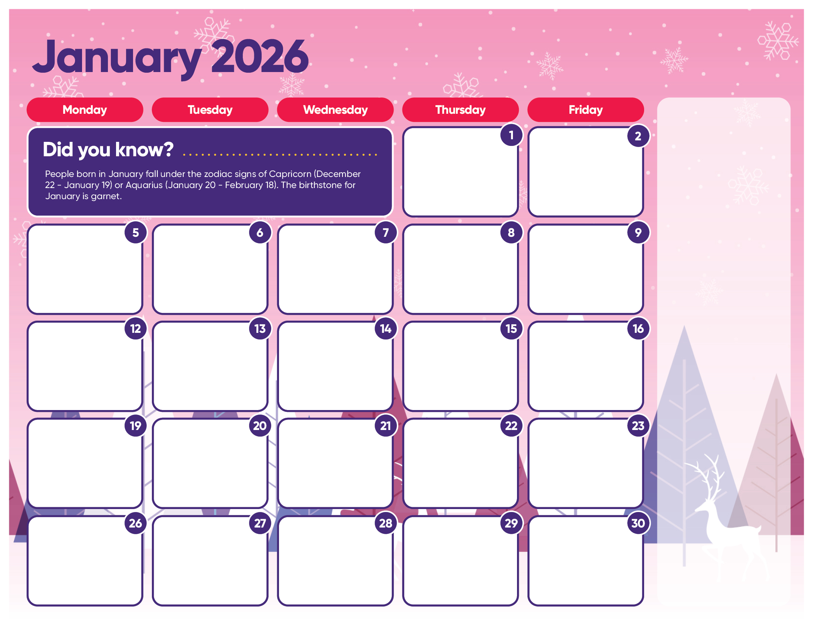
French Toast Sticks
Hash Brown
Dessert

Fish Sticks
Vegetable
Dessert

Meatball Sandwich
Vegetable
Dessert

Corn Dog
Vegetable
Dessert

Chicken Nuggets
Vegetable
Dessert

Cheese Omelet
Bacon
Dessert

Mac & Cheese
Vegetable
Dessert

Grilled Cheese
Tomato Soup
Dessert

Hamburger
Vegetable
Dessert

Chicken Fingers
Vegetable
Dessert

Pierogies
Vegetable
Dessert

Mini Waffles
Sausage
Dessert

Ravioli with Meatballs
Vegetable
Dessert

Cheeseburger
Vegetable
Dessert

Teacher Luncheon

Cafeteria closed

Vincenzo’s Pizza
Snack bag
Dessert

Vincenzo’s Pizza
Snack bag
Dessert

Vincenzo’s Pizza
Snack bag
Dessert

Alternate Lunches:

Pizza
Yogurt
Cereal

Alternate availability may vary each day.

12:00 Dismissal

No Lunch

School Closed

Happy New Year!

Lunches are $5.50 each

School Closed

MLK Day
School Closed

Christmas Break

