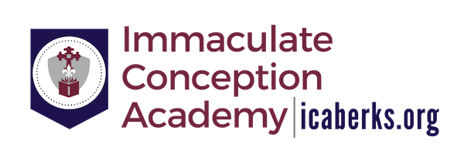

2019/2020 Tuition Rates – Grades K-8

Immaculate Conception Academy has approved the following Tuition Rates for 2019/2020.
Please note this is for 2019/2020 only; rates are subject to change annually.

# of Children Annual Rate Semi-Annual Quarterly Monthly
1 4,630.00 2,315.00 1,157.50 463.00
2 7,180.00 3,590.00 1,795.00 718.00
3 9,230.00 4,615.00 2,307.50 923.00
4+ 10,785.00 5,392.50 2,696.25 1,078.50

Non-Refundable New Student Registration Fee for K-8 is $100

2019/2020 Tuition Rates – Preschool and Pre K

Immaculate Conception Academy has approved the following Tuition Rates for 2019/2020.
Please note this is for 2019/2020 only; rates are subject to change annually.

Annual Rate Semi-Annual Quarterly Monthly
Preschool Rates – 3 year old students
Two Half Days 1,210.00 605.00 302.50 121.00

Pre K Full Day Rates – 4 year old students
Three Full Days 2,790.00 1,395.00 697.50 279.00
Five Full Days 4,380.00 2,190.00 1,095.00 438.00

Pre K Half Day Rates – 4 year old students
Three Half Days 1,750.00 875.00 437.50 175.00
Five Half Days 2,600.00 1,300.00 650.00 260.00

Non-Refundable New Student Registration Fee for Preschool and Pre K is $50

